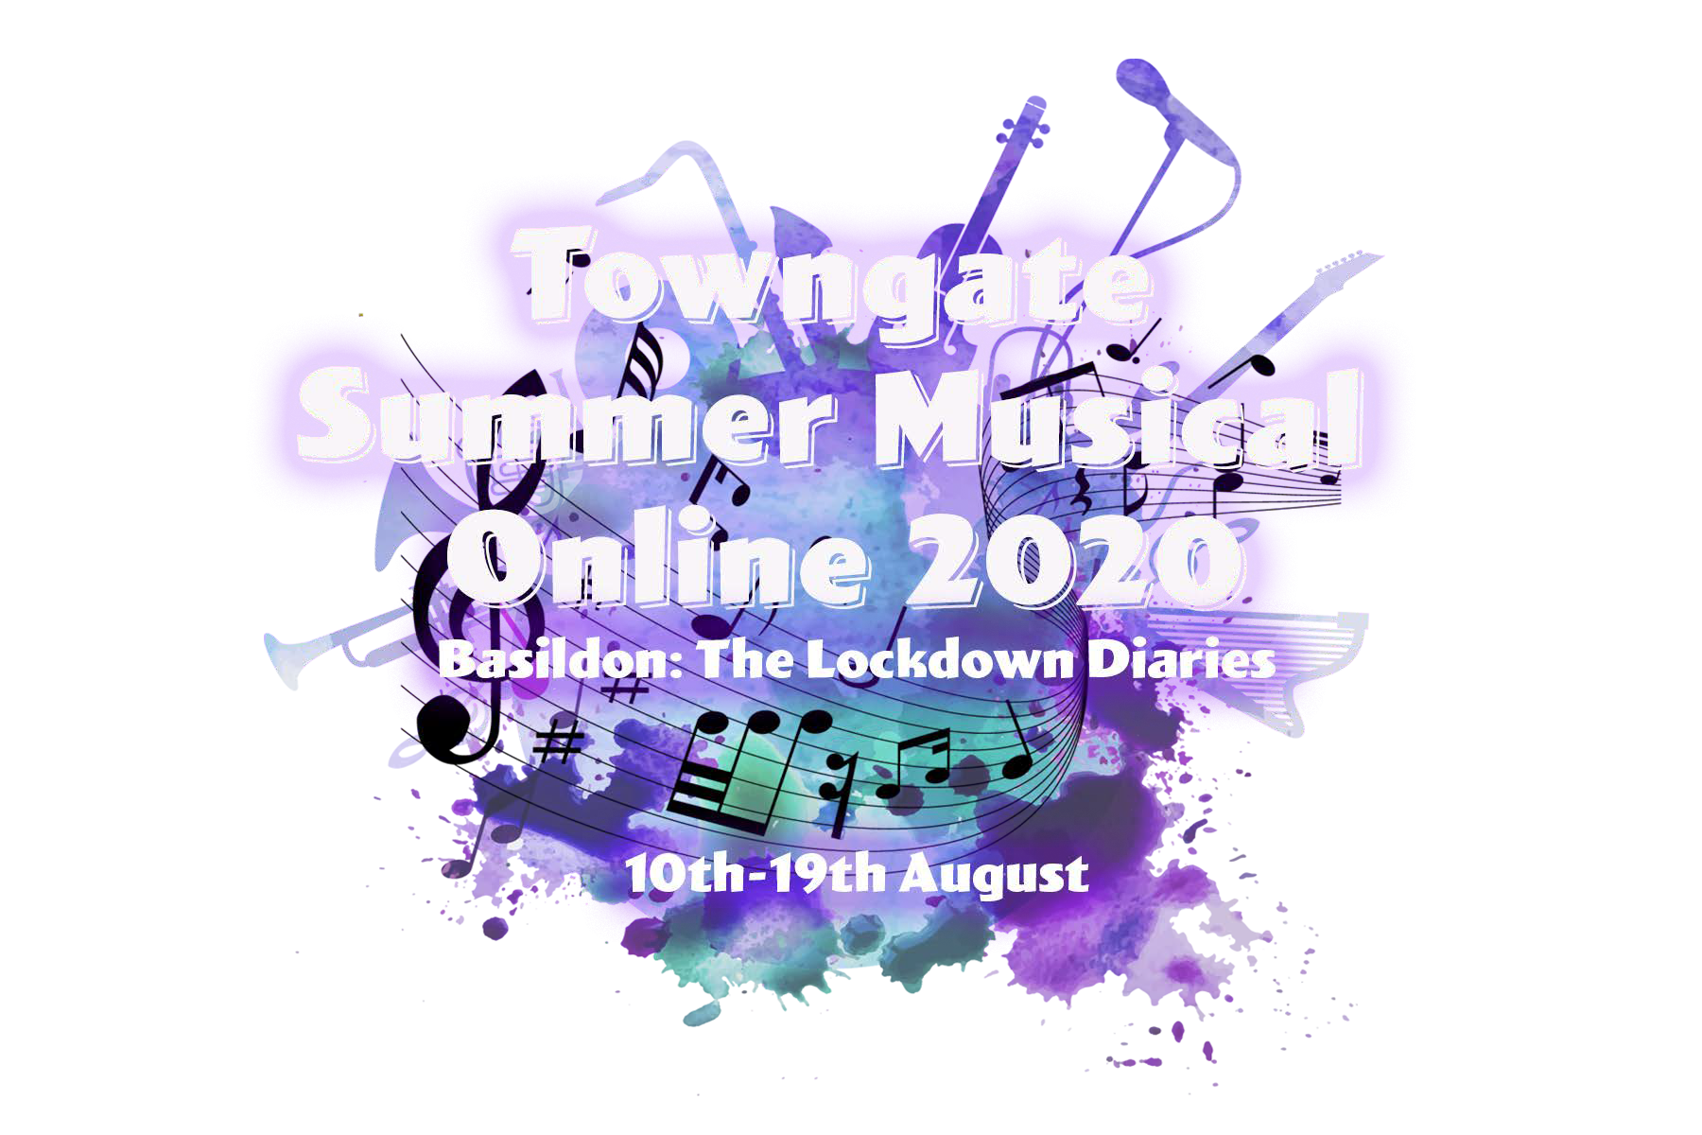

To register your child to take part in this year’s Online Summer School 2020 at the Towngate Theatre, please complete this form and return it to eando@basildon.gov.uk
Upon receipt of your completed form, please book your place online by visiting: https://towngatetheatre.co.uk/tss-basildon-lockdown-diaries/ . If you have any queries, please contact us on the email address above.
Please note: Young people must be aged 10 or above by Monday 10 August 2020 in order to take part.

PERSONAL DETAILS:
NAME OF CHILD/YOUNG ADULT
DATE OF BIRTH
AGE ON 10 AUGUST 2020
HOME ADDRESS
HOME TELEPHONE NUMBER
PARENT/CARER NAME & MOBILE NO
PARENT/CARER EMAIL ADDRESS

ALTERNATE EMERGENCY CONTACT DETAILS INC NAME AND PHONE NUMBER
WHAT WOULD YOU LIKE TO FOCUS ON FOR YOUR LOCKDOWN DIARY: ACTING, SCRIPTWRITING, SONG WRITING, SINGING, DANCING
PLEASE INFORM US OF ANY ALLERGIES/ILLNESSES OR CARE PLANS CONCERNING YOUR CHILD
PLEASE CIRCLE ONE OF THE FOLLOWING GIVING YOUR PERMISSION FOR THE TOWNGATE TO USE YOUR CHILD’S IMAGE IN MARKETING OR PRESS RELEASES, THEATRE DISPLAYS INCLUDING THE TOWNGATE THEATRE WEBSITE AND SOCIAL MEDIA OUTLETS, SHOW PROGRAMME ETC.. RELATED TO THE PRODUCTION | PERMISSION GRANTED  PERMISSION NOT GRANTED
GENERAL INFORMATION:
CHAPERONES AND DBS LICENSES | THE THEATRE WILL PROVIDE LICENSED CHAPERONES FOR FILMING DAYS
PARENT/CARER SIGNATURE
DATE

